Maprunf

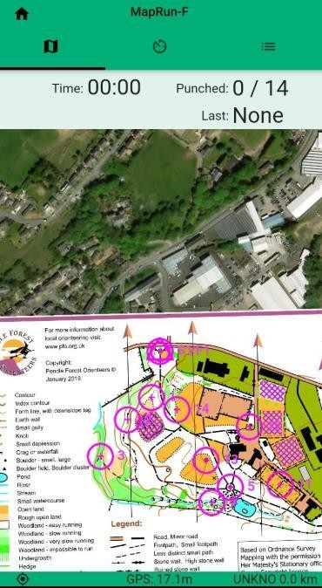
With MaprunF you are trying to post the fastest time visiting all of the virtual controls (purple circles) on the course. They are numbered 1, 2, 3, etc to show the order that you need to go to them.

You will not see any physical evidence of a control on the ground but will hear a 'beep' if you have got to the right location.

Your time is shown top left, 'Punched' 0/14 means you have visited no controls out of 14 on the course. 'Last' – The number of thecontrol you visited last.
The screen is split between a Google Maps overview of your location and the Orienteering map of the location.

- Download the MapRunF app on your smartphone from Google Play or the App Store
- Start the App
- Add your details
At the venue - select 'Events near me' and look for the title of the event you wish to do. Select 'go to the start'
You phone will make a sound when you pass through the event start and start the course timer. It will ‘beep’ each time you pass through a control. When you pass the Finish control it will ‘beep’ and automatically stops the timer.

Helpful Tips
- It’s much easier to navigate using a printed copy of the map.
- Make sure your phone is fully charged and turn up the volume so you can hear when you reach a control.
- Switch off other apps during your run.
- Make sure your 'Location Services' are turned on. For an iPhone go to 'Settings' then 'Privacy' - 'Location Services'// Android - 'Settings' – Tap Location – At top turn 'Use
Location' on.
- Switch off 'Auto-lock' for your screen. For iPhone - 'Settings' -'Display & Brightness' then switch 'Auto-Lock' to 'Never' // Android – 'Settings' – 'Security' – ' Screen Lock' – None.
- You need to visit all the controls in the correct sequence. If you miss one, go back to get it then carry on with the course from there, it may mean you need to go back to a control you’ve already visited.
- **If you run past a different control on route to your next number and hear a beep simply carry on and visit the number you're heading to, the app will correct itself when there.**
- Make sure you don’t run past the Finish control before you have been to all other controls on the course.

****Please respect social distancing rules, be aware of other park users and watch for cars on roads and car parks that may cross the course****

