Urban/ Street Orienteering

What is Urban Orienteering?

Urban Orienteering takes place on the streets mostly without the usual Orange/White Orienteering control flags of a traditional event. Instead you will be looking for controls on the map such as fire hydrants, lamp posts, post boxes, electricity substations telegraph poles and signs. When you find them you write down a simple answer on your answer sheet.

What are you looking for?

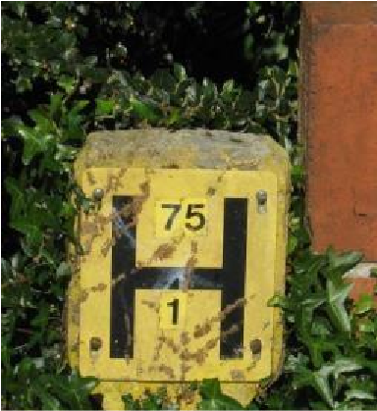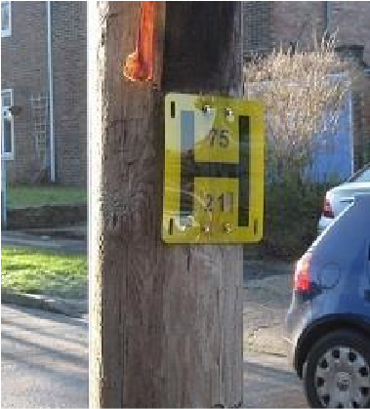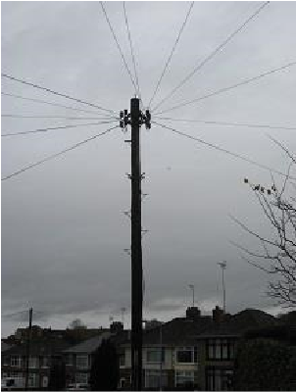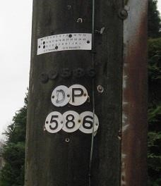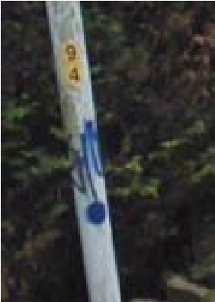
are usually two numbers. In these cases.
close to the ground or on a post. There
A letter H on a yellow background either
E.g DP586

Fire Hydrant

Telegraph Pole

Lamp Post

94

