MapRunF
Two different options for creating quick and easy virtual courses.
Quick Start
These are great if you're a bit bored of running/ walking and want to add a bit of navigation into your day. All you need is a georeferenced map and the app. Once you have a map of the area then you can plot as many courses as you like.
Great for Score courses. If you plot a large number of controls around your home/ a area you frequently run/walk in, then you can challenge yourself by running the course a number of times and seeing if you can better your score each time. Great for testing out route choice, is a more direct line over tougher terrain quicker for you or (if you're like me) are you likely to fall over numerous times and a longer less tussocky route is better!
Checksites
Want to share your course with a number of people but don’t want it to be an official event? You can upload your KMZ and KML files to the server, which will give you a code in return. You then type this into your app and off you go.
Unfortunately this doesn’t allow you to compare time/ route choice with others that have done the course.
For the Checksites option I'll show you have to use OOMap to create a Street O event.

Making a Georeferenced Map/ KMZ
First off you need a Georeferenced map, aka a KMZ map. This is basically a map with a little extra information that contains the coordinates for all points on the map.
If you don't have one of these then they are very easily made within the MapRunF app.
- First of all you need a image of a map, jpg, png. Unfortunately it doesn’t accept PDFs.
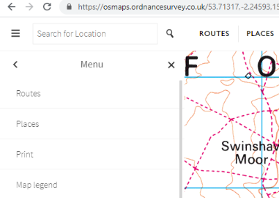
  - In my example I used a map from OS Maps online, https://osmaps.ordnancesurvey.co.uk/53.71314,-2.25858,15 If you don’t have this its hands down the best £20 I spend each year!
    - To export a map from it, sign in and choose the area you want, click on the 3 lines at the top left then click on 'Print'.
    - You can choose the scale and the image size. I'm going to go for 1:12500 and A4. It's now best to click 'Preview' to ensure that the PDF you're about to create contains all the area you want.
    - If it does then click print and under the printer choice there should be an option to save as PDF.
    - Once you have this, as mentioned before we need to convert from PDF to an image file. This can be easily done using https://smallpdf.com/pdf-to-jpg, just upload the pdf and a jpg will be available to download. Ensure you download in the best quality possible.
    - Now if you've done this on your computer you need to send the image file to your phone, Googledrive, email. Whatever is easiest for you. Alternatively this process can be done on your phone it just a little fiddly.
  - Other options for getting images of maps would be to scan/ take a photo of a map you already have. The only downside here is that the quality may not be great and the map itself needs to be as flat as possible so that the georeferencing doesn’t go wrong. There's also options such as https://opentopomap.org/ and https://maps.the-hug.net/. If you have a saved image of an orienteering map then this can also be used, depending on the age of the map it may not line up too well will the satellite image.

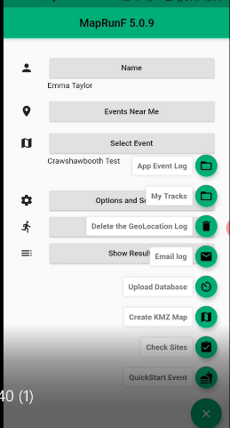
- So now you have your map image on your phone, open up the MapRunF app and click on the green button with 3 white lines at the bottom right. This will bring up a number of options and you want to click 'Create KMZ map'.
  - You will then be asked to select an image to be used. You can either take a photo of a map. Or use the image you created earlier.
    - If you're using the image you created earlier click on 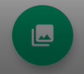 and this will bring up your file system. Find the image you want to use and click on it.
  - You will then see the image with a 'Use image for KMZ map' button. Make sure the image has north at the top and click on the 'Use image for KMZ map'.
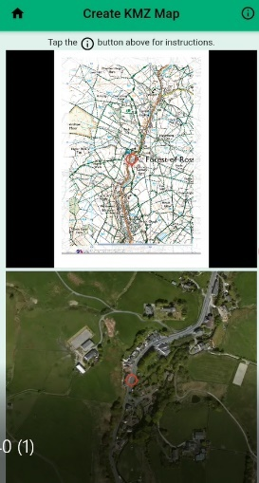
  - You will now see a split screen. The top has your map image with a red circle and the bottom has a satellite image, most likely of your current location, with a red circle.
    - The red dots are your 'pins'. To georeferenced the map, two locations are needed so that the app can work it's magic and create a coordinate grid on the image.
      - Ideally these two pins should be at opposite ends of the map and on very well defined features.
    - At the top right of my map image there is what appears to be a well defined road junction. In theory this should be perfect for a pin.
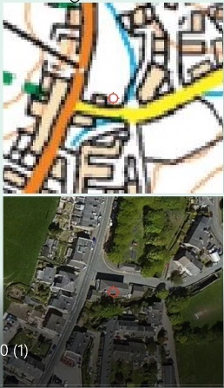
      - I move the top red dot onto this junction and then move the bottom red dot, on the satellite image, onto the junction. However when looking at it on the satellite image the junction is actually quite wide and it would be difficult to choose the correct location to put the bottom pin. You need to be exact as possible otherwise the georeferencing will be slightly off and you don’t want to be running round in circles waiting for that beep!
      - From the map I can see there is a road junction just right of the first one that will be ideal. So I place the red dots in the middle of the junction on both images and click 'Save pin 1'.
    - You then need to look for a well defined feature at the other end of the map. I found a path junction at the bottom left of the map so I repeat the process above and click 'Save pin 2'.
      - If you can't find good enough features at either end of the map then you can still give it a go but be sure to check that the two images line up throughout the map in the next step. If you've chosen two points in the middle then the georeferencing may be off as you radiate out of the map.
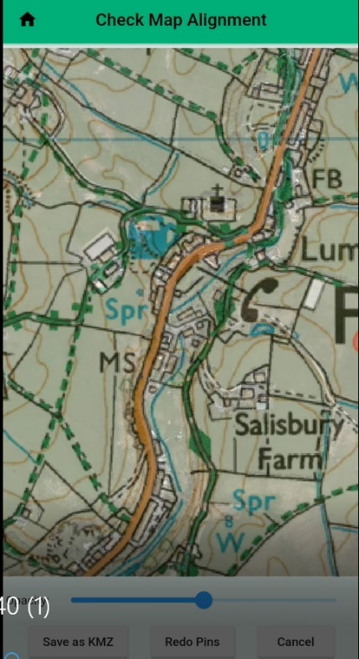
  - Now you can check the alignment of you map. You're presented with a screen that shows your map image layered over the satellite image. You can adjust the transparency if the satellite image is hard to see.
    - Here you want to check that features across the map line up on both the map image and the satellite image.
      - Good features to check are roads, field boundaries, large water bodies.
      - If they don't line up then click 'Redo pins' and try to make your pins more accurate.
      - If they do line up click 'Save as KMZ' and you have your first Georeferenced map!
        - Here you have the option to email the file to yourself. If you think you want to use the map for another purpose then its handy to have it saved somewhere easily accessible.
        - Enter your email address but depending on your phone you will get a variety of options. My old phone allowed me to whatsapp it, save it in a file etc. My new one just uploads it to Google Drive.
- So now you have your Georeferenced map you can start on your Quick Start course.

Making a QuickStart course
- Go back to the main screen, click the green dot with 3 white lines then click 'QuickStart event'.
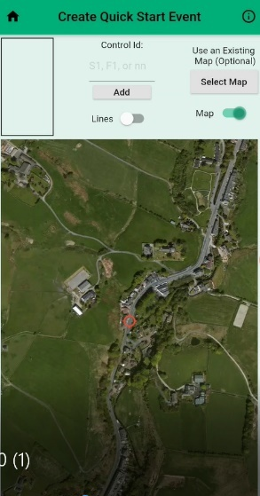
- You're then presented with a satellite image and a number of buttons.
  - Click on 'Use an Existing Map (Optional), Select Map'.
  - Find the Georefereneced map you created before, if you only have the one then it should be the only one there.
  - This will layer the map over the satellite image ready for you to plot a course.
- First of all you need to plot your start, place the red circle where you want the start to be and under 'Control Id' type 'S1' (needs to be capitalised). This will add a purple start triangle to your map.
- Now you're ready to plot your controls.
  - It's exactly the same process as plotting the start triangle but instead of typing 'S1' just type the number of the control.
    - The downside of a QuickStart event is that you can't move or delete controls once they're placed, if you go wrong then you have to start again.
  - Once your controls are plotted you can then plot your Finish, as before line up the red circle and type 'F1'
    - Make sure that you place your finish in a location that you won't run past it during the course. If you do then it will record you as finishing and you won't get to enjoy the rest of the course!
  - You can toggle the lines on and off, however this doesn’t affect the settings of the event and these need to be changed once saved depending on what type of course you want.
  - If you're happy with your course then you're now ready to save, it will be saved as a KML file.
    - You can either save or save and email. As before I prefer to save and email as I can then easily access the file if I need it for something else. Follow the process as you did for saving the map.
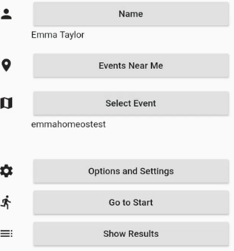
  - Now you're ready to try out your course, go back to the main menu and click 'Select Event'. Click 'Access Local Event (offline)', this will bring up all events saved on your phone. Scroll to find the event you just made and click on it.
  - Now, depending on what type of course you want it to be you have a few options. Courses are automatically saved as a scatter course, you can visit the controls in any order you want. If you prefer a linear or a score course then click on 'Options and Settings'
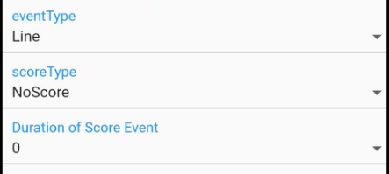
  - This will bring up quite a daunting screen but there's only a few settings we need to pay attention to.
    - If you want a linear course change eventType to Line and go back to the main menu.
    - If you want a score course then change eventType to Score. You then need to choose a Score Type.
      - http://maprunners.weebly.com/scoring-schemes.html - handy explanation
      - ScoreQ is the control number rounded down to the nearest multiple of 10.
ScoreV gives you 20 points per control.
      - ScoreB splits the controls into odds and evens groups. You can start on either but once you change to the other group you can't go back.
  - Once you've chosen your settings you can then go back to the main screen, click 'Go to Start' and enjoy your course!
Sharing with others:
If you want to share your QuickStart event with someone then it can be done. You can either follow the process below or use Checksites to upload the two files, this is explained in the next section.
- You need to send them the KMZ map and the KML course files to them.
- They need to click on 'Select Event', 'Access Local Event', 'Import a personal Event'.
  - They will then get a prompt asking them to create a folder within the 'Events' folder. Mine asks me to create it in /Android/data/au.com.fne.maprunf/files/Events/*create the folder here.
  - The KMZ and KML files can then be saved in this folder.
    - Its important to ensure that the map file is saved as the same name it has when you use the map within the app.
  - Once saved the other person should then be able to run that event.

CheckSites and OOMap.
https://oomap.co.uk/ - a brilliant website that has created an orienteering map of the world.
It's uses openstreetmap, which is an opensource map created by it's users. Similar to Wikipedia. The great thing about this is that if you notice something missing from the map such as a footpath you can easily add it. Just go to https://www.openstreetmap.org/, you will need to create an account but then all you need to do is click 'Edit' and it will allow you to draw in the missing features. More info about this can be found here, https://www.openstreetmap.org/help. It does take a day for the changes to show on OOMap.
- To start your OOMap MapRunF go to oomap.co.uk, scroll down and you will see a red section called 'OpenOrienteeringMap: The easy Street-O map creation tool', click on the red UK button and it will bring up the map screen.
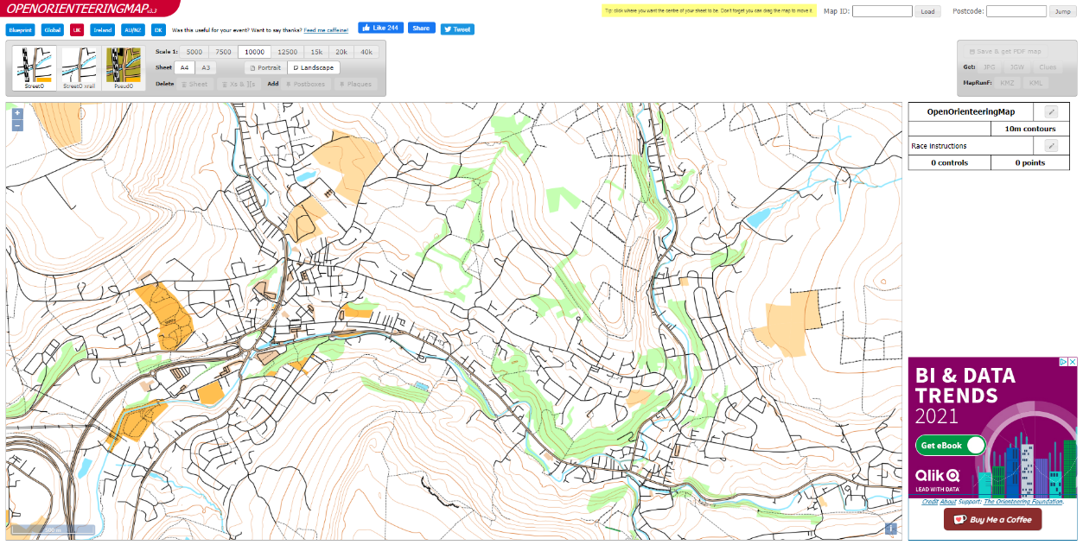

- Zoom in on the area in which you want to create your course. For this example I've chosen Rawtenstall.
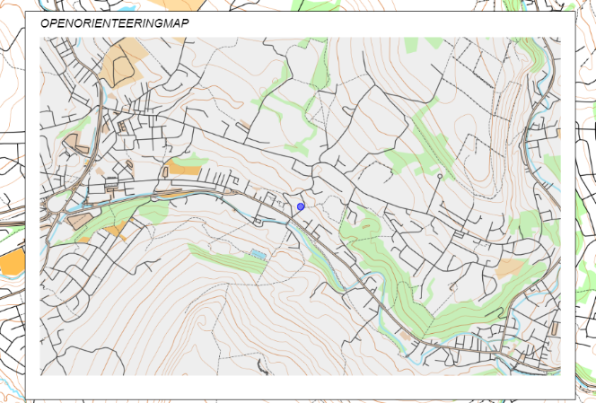
- Once you have your area in view simply click on the map and it will place a blue dot and an overlay showing the map area you have chosen.
  - You can change the scale on the map at the top of the screen, 5000 to 40k are available. You can also choose whether you want an A4 or A3 sized map as well as portrait or landscape.
  - If you want to reposition the overlay just click on the blue dot and a white outline will appear. Click and drag the dot to the new position.
  - There are also 3 different types of map, SteetO, StreetO xrail and PseudO. It's worth clicking on each to see which map you think displays the best information for the type of course you will be plotting.
- Now you have a map and you're ready to plot your start and finish point. There can only be one start/finish location so it's important to place it in a location that you're not going to run past mid-way through the course. Or just remember to stay away from it!
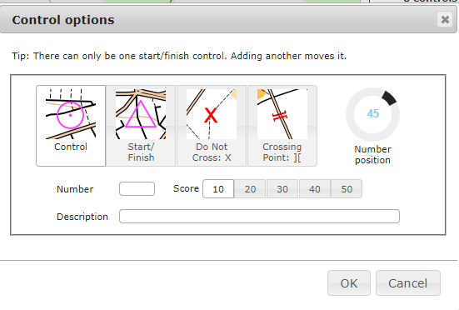
  - To place the control click on the map in the location you'd like to place it and you will see this screen, click on Start/Finish and then OK.
- You can now place your controls, click where you'd like to place your first control and it will bring up the same screen as before, click on Control and type in the control number. Click OK and it will be added to the map.
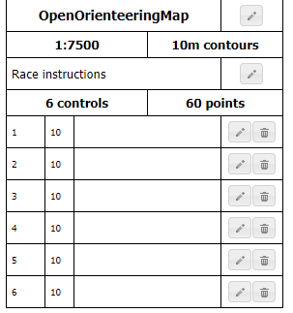
  - If you misplace a control or want to move it then it needs to be deleted from the Control Description section. Click on the Bin to delete and the Pen to edit.
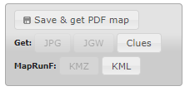
- Once all controls are place then you're ready to create the files you need to upload to MapRunF.
  - Click on 'Save & get PDF map', this will create a PDF map and open up further options.
  - You will see that both the KMZ and KML buttons are clickable now. Click on both to download.
- To upload to MapRunF go to http://www.p.fne.com.au/#/checksitesupload
  - First you need to give your course a name. If you want it to be a linear course then include PXAC in the name eg Marl Pits PXAC. Don't worry you can also change the course type in the settings later.
  - Set an expiry date for when the course will be removed from the server.
  - Add you name and email address, I've yet to be contacted so don't worry!
  - Then you can upload your map, KMZ file. Click on 'Choose File' and navigate to the location that your files were downloaded to. You should then see your map KMZ file.
  - Repeat for the course KML file.
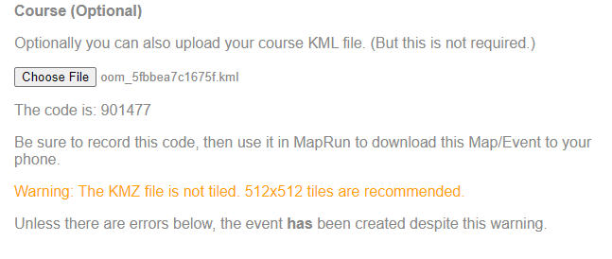
  - Click Submit, give it a few seconds and you will see the following.
If you receive the orange warning you can just ignore as long as you get a code. The code for the course I just created is 901477. Make a note of your course code as you will need this to access the course on your phone.
- Now open up your phone and go to the MapRunF app.
  - Click on the 3 white lines to bring up the menu
  - Click Check Sites
  - Enter the 6 digit code from the website upload
  - The course will be downloaded to your phone and ready for you to enjoy!
Hints and tips:
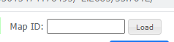
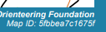
- If you want to make changes to your course after you have ran it, eg a control isn’t in the right place then look at the bottom left of the OOMap you created and you will see a Map ID. You can enter this into the top of the OOMap website and it will reload your map and course.

- If you want to share your course with someone else just give them the 6 digit code, there won't be a leaderboard to compare times and routes though.
- If you've created an great course that you think others will enjoy, you've ran it and all the controls are in the right place then send Andy Ellis an email with the KML and KMZ files and he will be able to upload it as a 'proper event'.

